Change Request Form

Change Request details
Change Request details
Change Request Title | Delay to Elexon Level 3 validation response – NFR (1009)
Change Request Number | CR034
Originating Advisory / Working Group | NFTWG
Risk/issue reference
Change Raiser | Nigel Rees, Elexon | Date raised: | 17 Oct 23

For further guidance on how to complete this document please see the supporting Change Request Form Guidance for Programme Participants. The guidance will support raising a change and responding to a change request via Impact Assessment. The Change Raiser should consider sharing the draft Change Request Form with impacted programme parties, prior to submission to PMO. The guidance, as well as other key documents are referenced below and can be found via the MHHS website.

Change Request to be read in conjunction with:
MHHS Change Request Form Guidance for Programme Participants
MHHS Change Control Approach
MHHS Governance Framework
Ofgem’s MHHS Transition Timetable

Part A – Description of proposed change
Guidance – This section should be completed by the Change Raiser when raising the Change Request.

Part A – Description of proposed change
Issue statement:
(what is the issue that needs to be resolved by the change)

Helix Data Acquisition Hub which interfaces with DIP has been designed with a micro batch architecture. This architecture was chosen based on the functional and non-functional requirements available during the design phases. The architecture enables Helix to process the large quantities of data and respond as per the timings detailed in the operational choreography.

Given Helix operational responses are detailed separately, it has been clarified by MHHS that the level 4 validation referred to in E2E1009 required technical validation responses only from Helix i.e. schema validation.

Currently Helix de-queues all messages and provides a Level 4 technical validation response between 1 and 10 minutes back to DIP and not within 6 Seconds as detailed in E2E1009.

Description of change:
(what is the change you are proposing)
The change being proposed is that Helix does not meet the requirements of E2E1009 NFR. We request the description for E2E1009 be updated to read “All Services shall provide an asynchronous response (Level 4 validation) to a message within the following timeframes - 10minutes or less – excludes IF-021”

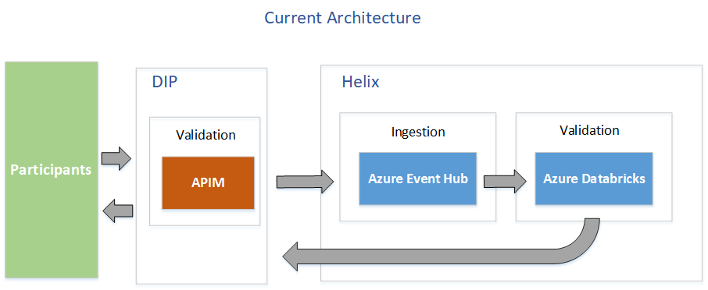

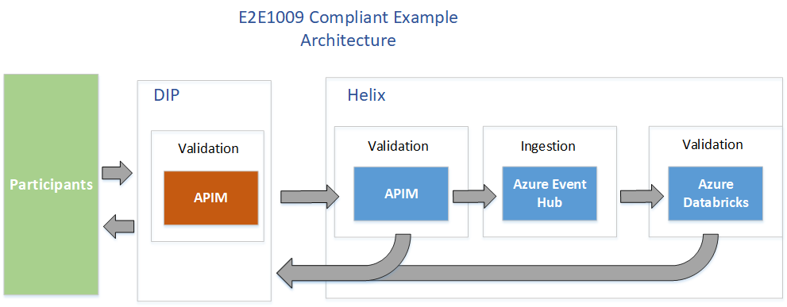

Justification for change:
(please attach any evidence to support your justification)

Given the DIP itself technically validates the schema of all incoming requests, the only scenario where Helix would receive and respond to an invalid request is if it’s validation and schema was out of sync with DIP’s message schema.
The only time this could occur is during a production release when testing had not picked up the misalignment between DIP and Helix. There is a very small chance of this occurring. If this did happen it is not clear what the benefit of a 6 sec response to DIP would be given the associated additional costs.
Helix is not a real time system. It is responsible for providing settlement calculations at the end of a settlement day.

Consequences of no change:
(what is the consequence of no change)
No change to the E2E1009 Non-functional requirement with regard to Helix, will mean Helix will have to implement additional infrastructure in front of the current DIP message receiver to process and respond to schema validation failures. Apart from the additional running cost to industry of approx.. £5000 per month, there will be a build cost including additional performance testing. The additional infrastructure will also incur ongoing maintenance and support costs.
Alternative options:
(What alternative options or mitigations that have been considered)
There are a couple of ways to implement the infrastructure to respond in 6 seconds. Both have similar overall costs.
Risks associated with potential change:
(what risks related to implementation of the proposed change have been identified)
The change to the NFR requirement is that we don’t meet the NFR and continue with the infrastructure as is. This offers less risk in terms of the robustness of Helix.

Given DIP will respond to the participant directly regarding schema validation errors, the only time Helix would respond is if Helix deployed a version of the schema that did not align with DIP. The risk of this is considered very low as releases require significant schema version testing. If however this did occur there is a risk a response would take up to 10 minutes. Given the time it would take to remediate the situation it’s not clear if this level of delay would be detrimental.
Stakeholders consulted on the potential change:
(Please document the stakeholders, or stakeholder groups that have been consulted to date on this change. The Change Raiser should consult with relevant programme parties in the drafting of the request, prior to submission to PMO).
MHHS Design Team
MHHS Non Functional Testing team

Target date by which a decision is required: | 13 Dec 2023

Part B – Initial Impact of proposed change
Guidance – This section should be completed by the Change Raiser before being submitted to the MHHS PMO.
Please document the benefits of the change and to delivery of the programme objectives

What benefits does the change bring
(list the benefits of the change and how this improves the business case)

Programme Objective | Benefit to delivery of the programme objective
To deliver the Design Working Group’s Target Operating Model (TOM) covering the ‘Meter to Bank’ process for all Supplier Volume Allocation Settlement meters
To deliver services to support the revised Settlement Timetable in line with the Design Working Group’s recommendation
To implement all related Code changes identified under Ofgem’s Significant Code Review (SCR)
To implement MHHS in accordance with the MHHS Implementation Timetable
To deliver programme capabilities and outcomes to enable the realisation of benefits in compliance with Ofgem’s Full Business Case
To prove and provide a model for future such industry-led change programmes

Guidance – Please document the known programme parties and programme deliverables that may be impacted by the proposed change

Impacted areas | Impacted items
Impacted Parties
Impacted Deliverables
Impacted Milestones | <Ofgem’s MHHS Transition Timetable is linked above>

Note – Please refer to MHHS DEL174 Change Request Guidance for Programme Participants for information on how to score the initial assessment.

Initial assessment
Necessity of change |  | Expected lead time
Rationale of change |  | Expected implementation window
Expected change impact

Guidance – Please include a reference and link to any additional documentation which the change relates to.
Change Request to be read in conjunction with:
Title | Reference

Part C.1 – Summary of Impact Assessment

Note – This section will be completed initially by the Change Raiser and then by Programme Participants as part of the full Impact Assessment.

All Impact Assessment responses will be considered public and non-confidential unless otherwise marked. If there are any specific elements of the response (e.g. costs) that are confidential, please mark the specific sections as confidential rather than the response as a whole. The MHHS Programme will publish all Impact Assessment responses and redact any confidential information as noted.
Guidance – Programme Participants are required to:
- Respond with ‘Agree’, ‘Disagree’ or ‘Abstain’, deleting as appropriate. If the respondent agrees, they can provide additional evidence to further support the assessment. If the respondent disagrees or abstains, they should provide a detailed rationale as to why.

- Add any additional effects that have not already been identified. In doing so, they should provide as much detail as possible to allow a robust assessment to be made.

- Proceed to Part C.2 for Impact Assessment Recommendation response once completed.

Part C.1 – Summary of Impact Assessment (complete as appropriate)
Effect on benefits
There will not be an impact on other participants due to this change as the DIP already responds with technical schema validation.

<Delete as appropriate>: Agree Disagree Abstain
Impact Assessment respondents to add supporting commentary to support their selection. Where possible, Impact Assessment respondents to identify and describe any further impacts.
Impact Assessment respondents should consider and provide detail of any additional effect e.g. whether there will be an impact on when a benefit will be realised; who will realise the benefit; the extent to which the benefit will be realised.
Where possible, contextual information should be included e.g. the benefit will be delayed by X weeks; the change means Y population will also realise the benefit.
Effect on consumers
There will not be an impact on other consumers due to this change as the DIP already responds with technical schema validation.

<Delete as appropriate>: Agree Disagree Abstain
Impact Assessment respondents to add supporting commentary to support their selection. Where possible, Impact Assessment respondents to identify and describe any further impacts.
Impact Assessment respondents should consider and provide detail of any additional effect e.g. whether there will be an impact on service delivery to consumers; will there be a cost impact to consumers; will there be a choice impact to consumers?
Where possible, contextual information should be included e.g. what is the scale of the effect? Will the effect be permanent?
Effect on schedule
As this change involves retaining the current architecture, it will have no impact on the schedule. Not accepting the change from the required NFR will require additional work that may impact the schedule.

<Delete as appropriate>: Agree Disagree Abstain
Impact Assessment respondents to add supporting commentary to support their selection. Where possible, Impact Assessment respondents to identify and describe any further impacts.
Impact Assessment respondents should consider and provide detail of any additional effect e.g. will the schedule/milestones be directly impacted; will the schedule/milestones be indirectly impacted.
Where possible, contextual information should be included e.g. the change will delay the project by X days; the change will require additional resource to complete (though detail resource in resource section); the delay can/cannot be recovered by condensing Y activity.
Effect on costs
As this change involves retaining the current architecture, it will have no impact on the cost. Not accepting the change from the required NFR will require additional work that will increase operational and DBT costs.

<Delete as appropriate>: Agree Disagree Abstain
Impact Assessment respondents to add supporting commentary to support their selection. Where possible, Impact Assessment respondents to identify and describe any further impacts.
Impact Assessment respondents should consider and provide detail of any additional effect e.g. will the change cause a loss of income; will the change cause additional cost; will the change cause a reprofiling of cost?
Where possible, contextual information should be included e.g. whether it is capital or operating expenditure that will be affected; what period costs will be affected in; what the rough order of magnitude of the cost impact will be and if organisation will be able to absorb it?
Effect on resources
As this change involves retaining the current architecture, it will have no impact on resources. Not accepting the change from the required NFR will require additional work that may impact resourcing.

<Delete as appropriate>: Agree Disagree Abstain
Impact Assessment respondents to add supporting commentary to support their selection. Where possible, Impact Assessment respondents to identify and describe any further impacts.
Impact Assessment respondents should consider and provide detail of any additional effect e.g. will there be an impact on tools or equipment; will there be an impact on staff capacity; will there be an impact on staff skills or capability?
Where possible, contextual information should be included e.g. the change will require X additional staff for Y period of time; the change requires Z training or support.
Effect on contract
As this change involves retaining the current architecture, it will have no impact on contract. Not accepting the change from the required NFR will require additional work that may impact.

<Delete as appropriate>: Agree Disagree Abstain
Impact Assessment respondents to add supporting commentary to support their selection. Where possible, Impact Assessment respondents to identify and describe any further impacts.
Impact Assessment respondents should consider and provide detail of any additional effect e.g. whether there will be an impact on contracts with sub-contractors; whether there will be an impact on contracts with vendors; whether there will be an impact on contracts with regulators/ESO.
Where possible, contextual information should be included e.g. the changes will require new contracts to be created; the changes will variations to existing contracts; the changes will affect ability to meet contract requirements.
Risks
As this change involves retaining the current architecture, it does not introduce risks. Not accepting the change from the required NFR will require additional work and additional infrastructure that may introduce additional operational and DBT risks.

<Delete as appropriate>: Agree Disagree Abstain
Impact Assessment respondents to add supporting commentary to support their selection. Where possible, Impact Assessment respondents to identify and describe any further impacts.
Impact Assessment respondents should consider and provide detail of any additional effect e.g. will existing risks be affected; will new risks be created?
Where possible, contextual information should be included e.g. the change will affect the likelihood of a risk occurring, the change will affect the impact the risk would have, the change will require additional controls and mitigation.

Part C.2 – Impact Assessment Recommendation

Note – This section must be completed initially by the Change Raiser and then by Programme Participants as part of the full Impact Assessment.
Guidance – The primary reporting metric of the Impact Assessment is the recommendation response. The consolidated response will be presented to the relevant governance group(s) and decision maker(s) with the totals for ‘Agree’, ‘Disagree’ or ‘Abstain’. As such, please ensure this section is completed before the form is returned to MHHS PMO. Provide detailed rationale and evidence in the commentary field.

Part C.2 – Impact Assessment Recommendation (mandatory)
Recommendation
Change Raiser to provide initial recommendation.
It is recommended by the Change Raiser the change is approved.
<Delete as appropriate>: Agree Disagree Abstain
Impact Assessment respondents to add supporting commentary to support their selection.

Impact assessment done by: <Name>

Guidance: If you are a third party responding on behalf of another Programme Participant, please state this in your response.

Impact assessment completed on behalf of: <Name>

Part D – Change approval and decision
Guidance: The approvals section will be completed by the MHHS PMO once the Impact Assessment has been reviewed.

Part D - Approvals
Decision authority level
<Based on the impact assessment, state who is required to make a decision concerning this change>

Guidance - This section will be completed by the MHHS PMO and Change Owner following the review of the impact assessment and decision reached by the SRO.

Part D – Change decision
Decision: |  | Date
Approvers:
Change Owner:
Action:
Changed Items | Pre-change version |  | Revised version

Part E – Implementation completion
Guidance - This section will be completed by the MHHS PMO at the end of the post-implementation process.

Part E – Implementation completion
Comment |  | Date

Guidance – The Closure Checklist in MHHS DEL175 Change Log must also be completed by MHHS PMO at this stage.

Checklist Completed | Completed by
Yes/No

Guidance – This section will be completed by the MHHS PMO at the end of the post-implementation process and should be used to add any appropriate references of the change once it has been completed.

References
Ref | Document number | Description

